This is the ambari folder where i stored the .csv file in it is named STOCKS

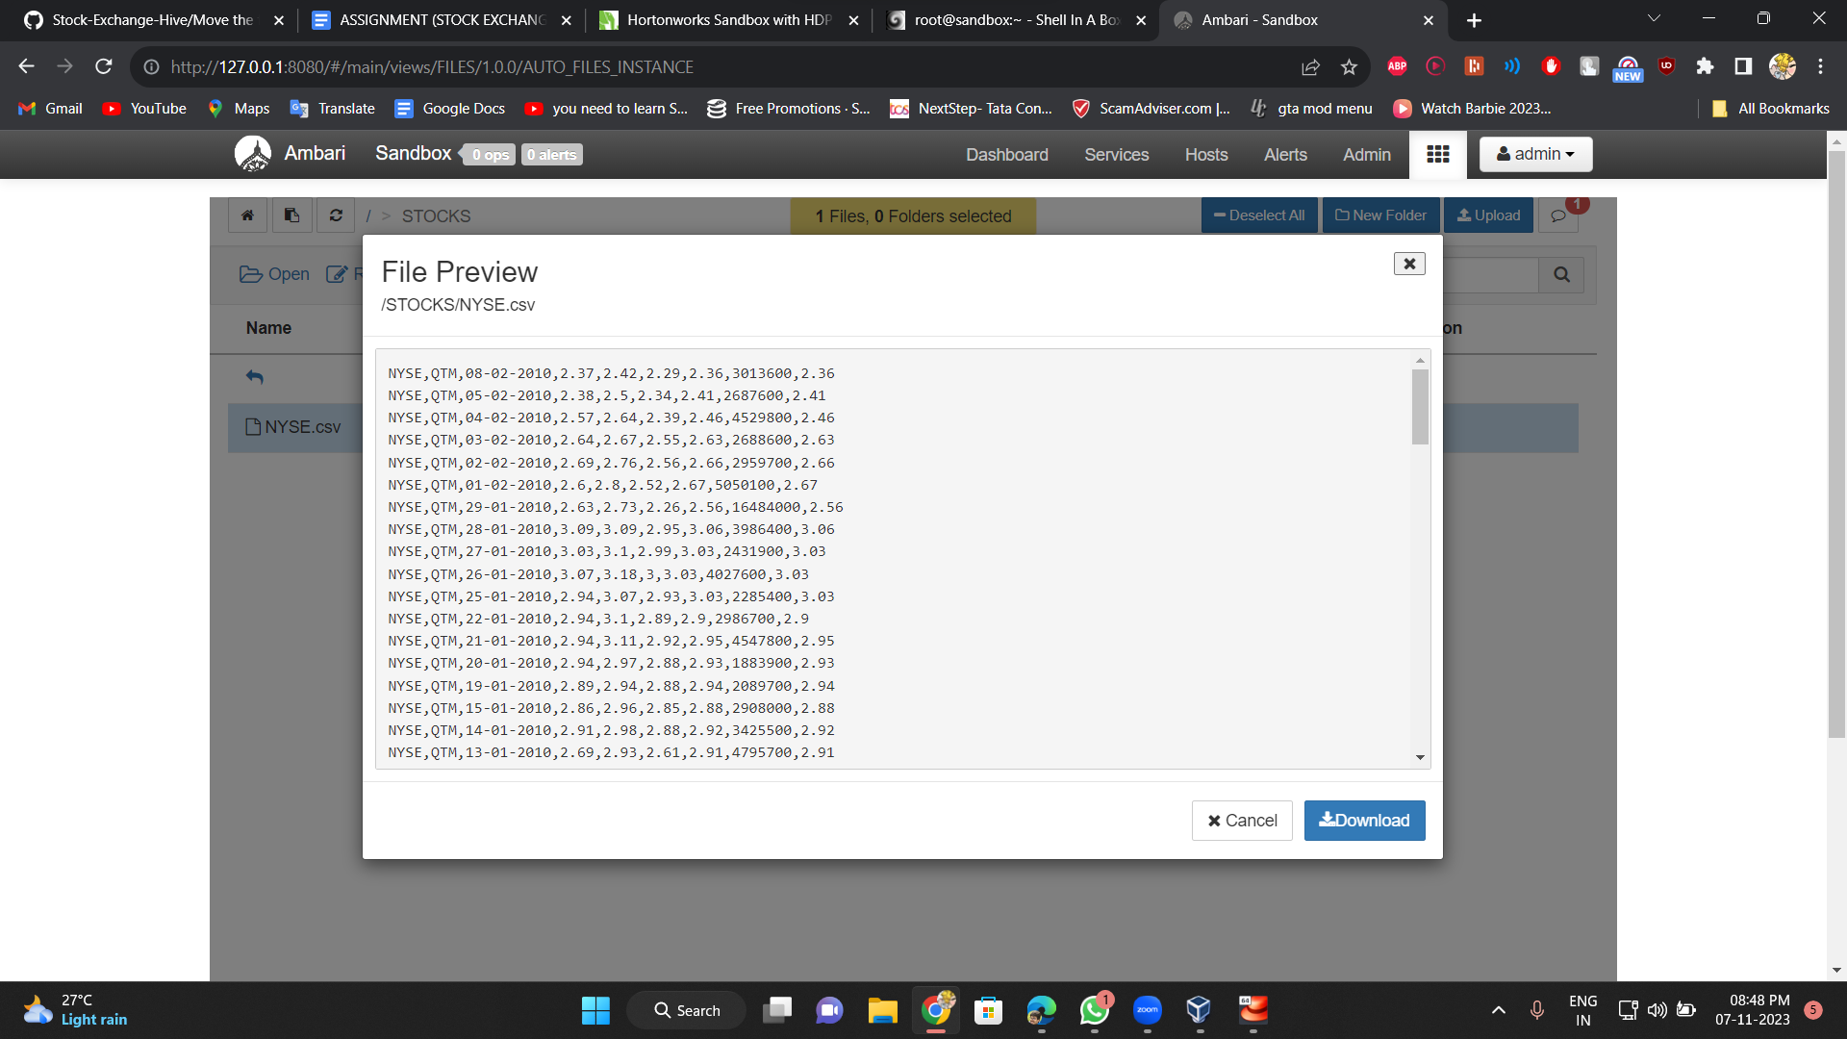

Now you can get this file into local by using the get command

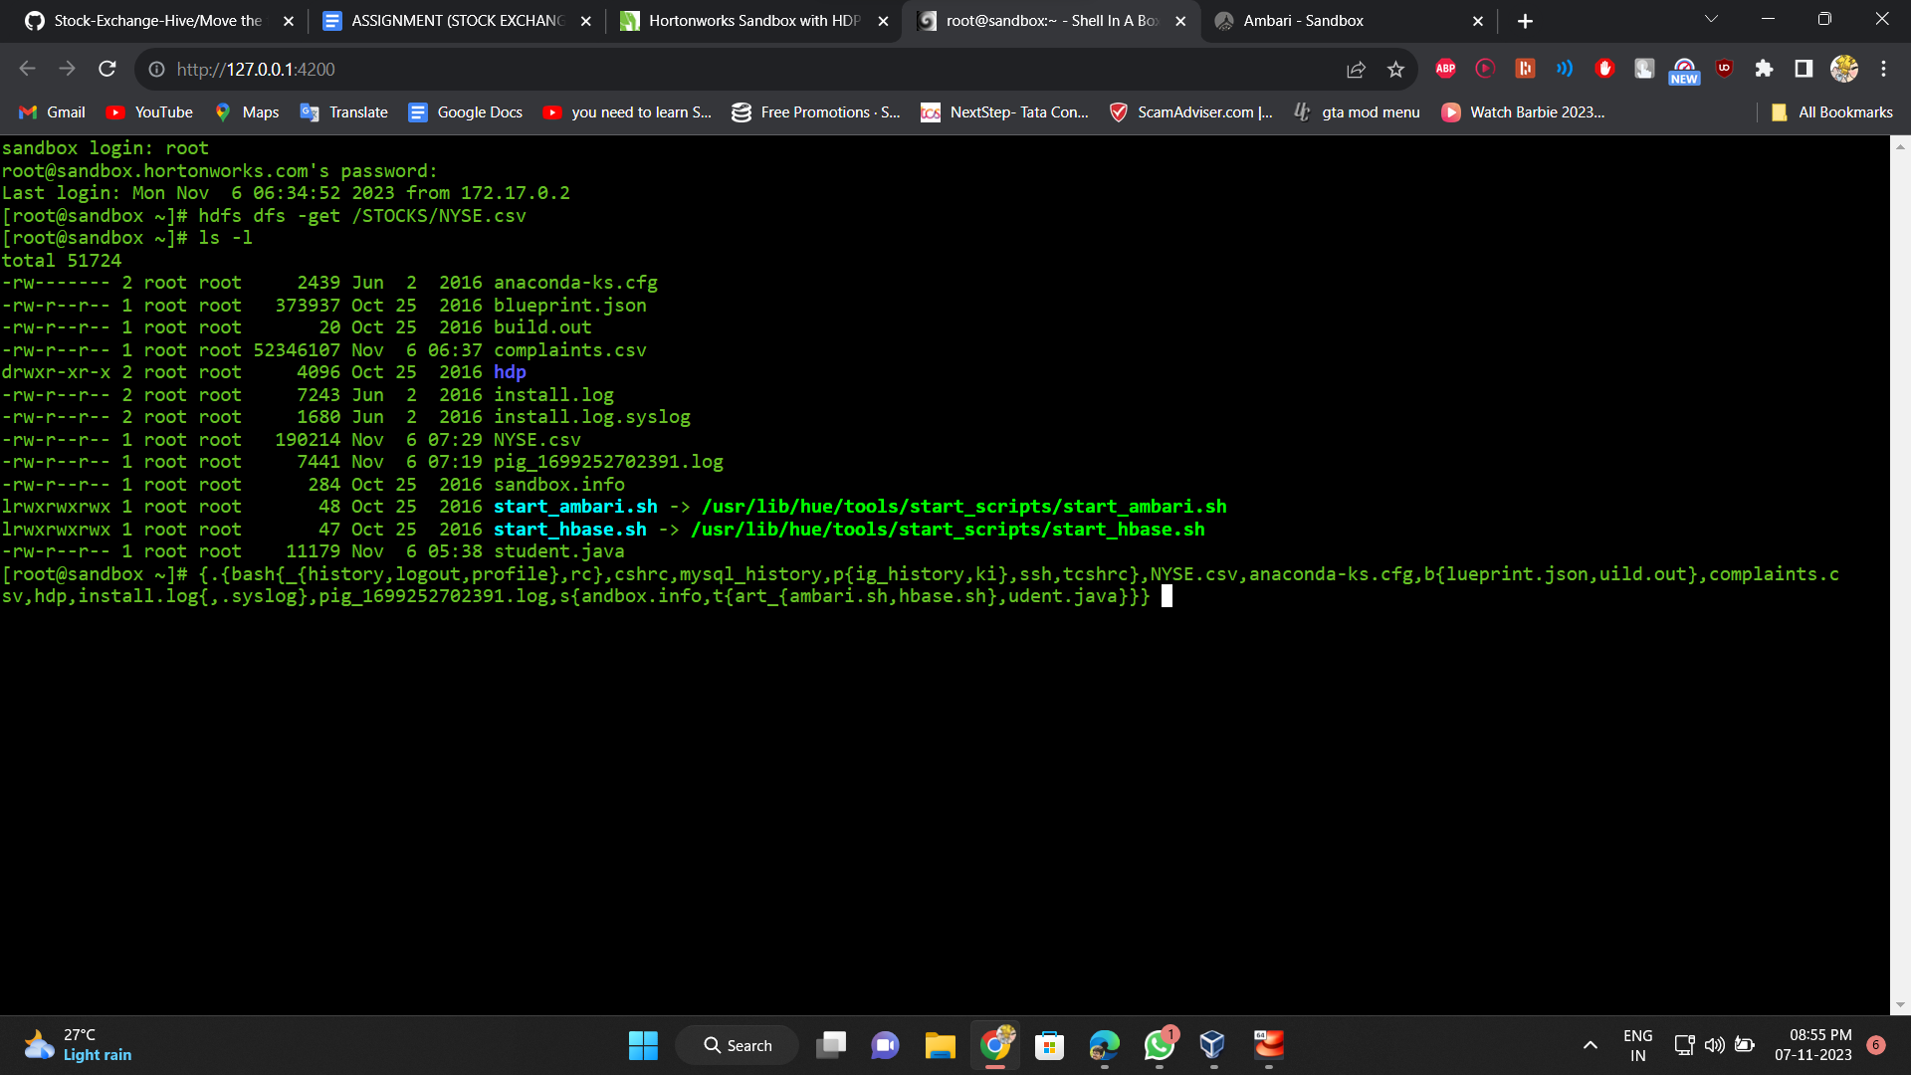

You can check if its available by using ls -l

Now you can enter hive by typing hive and create a database and an empty table to upload the .csv file

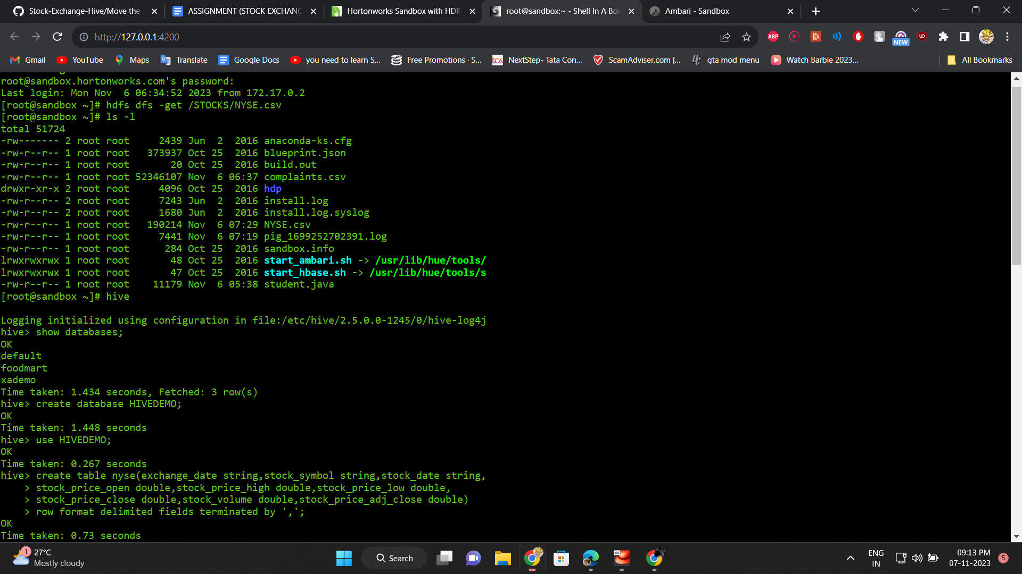

Now load the data into the table by load local command and enter the hive query as below to start the mapper and reducer task with a JOIN operation

